**Prompt Bibliothek – Video Generierung mit KI**

**Rose Timelapse Video**

**Prompt für die Rose**

Tightly closed rose bud, slight green and red tones, morning dew droplets, soft backlight bokeh garden background, macro photography, shallow depth-of-field, realistic water refraction.

**First Frame für Video**

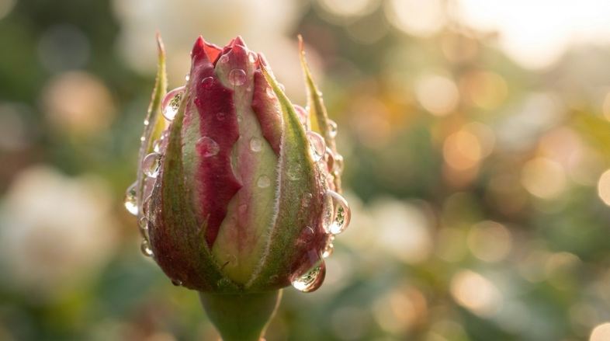

**Last Frame für Video**

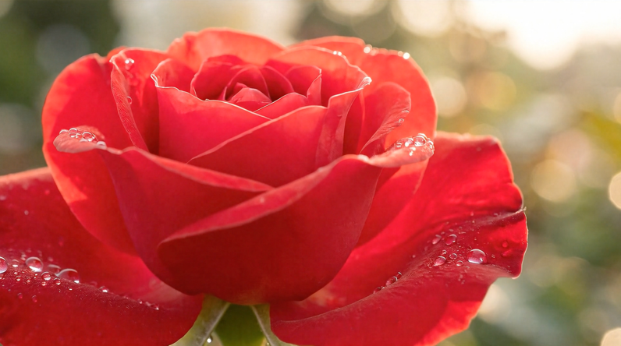

**Prompt für Timelapse Video**

Macro timelapse of a rose bud slowly opening and blooming into a full flower. Petals unfold smoothly, dew forms and evaporates, light moves through golden morning phase. Velvet texture and fine detail in petals, cinematic macro realism.

**Seasonal Timelapse**

**Prompt für den Baum**

Large oak tree full of deep green leaves in bright summer sunlight, lush grass field, warm blue sky with soft white clouds, vibrant color palette, peaceful midday glow, ultra-realistic, 50mm natural lens feel.

**First Frame Bild**

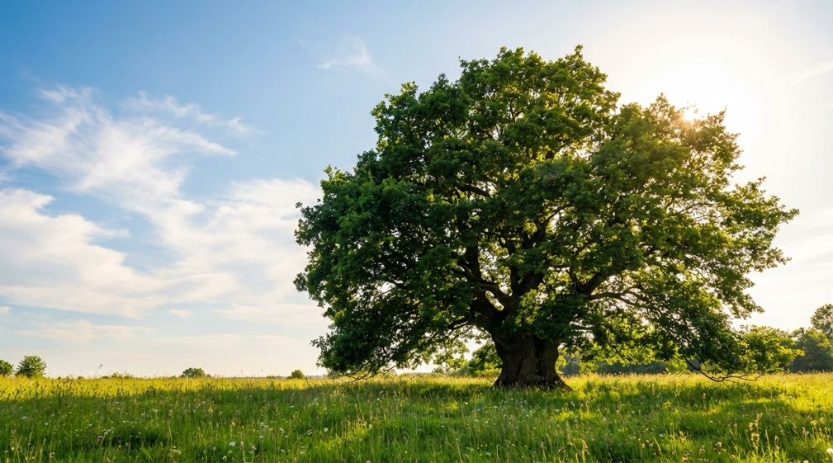

**Last Frame Bild**

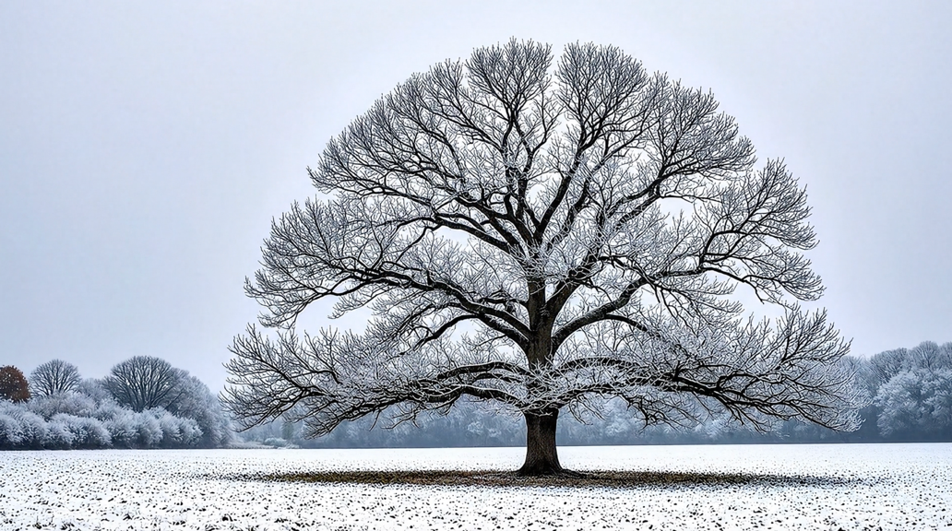

**Prompt für Timelapse Video**

Timelapse of an oak tree shifting through seasons: vivid green summer leaves, gradually turning bright orange and red in autumn, falling and swirling in wind, branches becoming bare and covered in frost and snow under a pale winter sky. Smooth atmospheric seasonal transitions, realistic weather shifts, dramatic lighting changes.

**Day to Night Timelapse**

**Prompt für den Tag**

City skyline at sunrise, soft golden morning light illuminating glass skyscrapers, sky with warm orange and pink gradient, calm river reflecting buildings, light morning haze, minimal car traffic, clean and peaceful mood, ultra-realistic 8K, 35mm lens, crisp clarity.

**First Frame Bild**

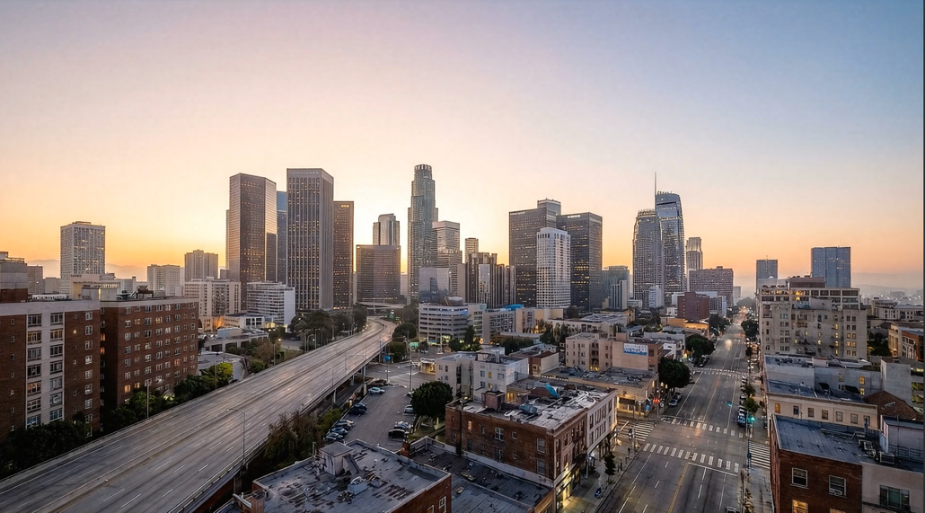

**Last Frame Bild**

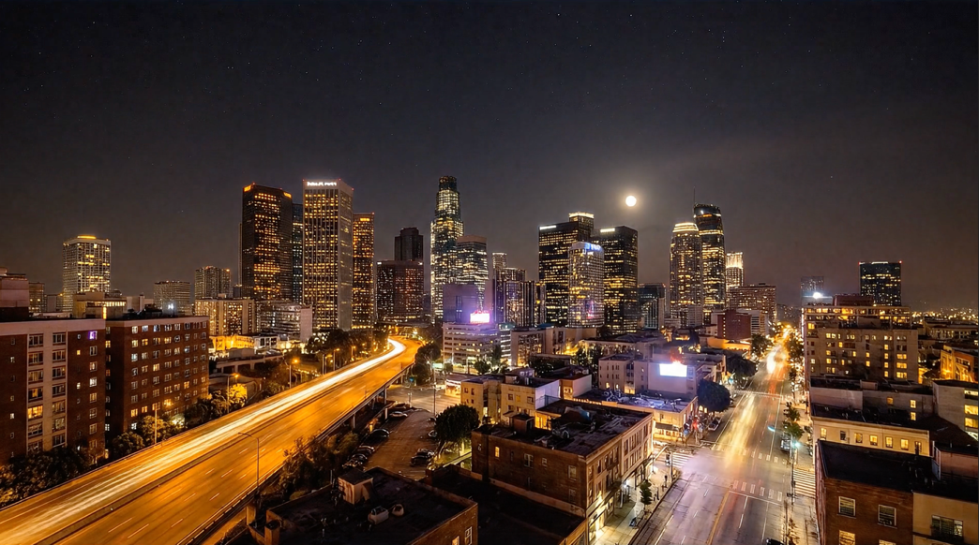

**Prompt für Timelapse Video**

Timelapse of a modern city skyline transitioning from sunrise to full night. The sun rises and climbs across the sky, shadows moving across skyscrapers, clouds racing overhead. As the sky darkens, city lights turn on, neon signs glow, car lights streak through the streets, moon rises and reflects in the river, stars appear. Ultra-realistic, cinematic lighting, smooth time transition, IMAX wide angle.

**Baustelle Timelapse**

**Prompt für die erste Szene der Baustelle**

Bare ground construction site with cranes, rebar frames, concrete foundation grid, dirt piles, early morning industrial light, scattered tools and equipment.

**First Frame Bild**

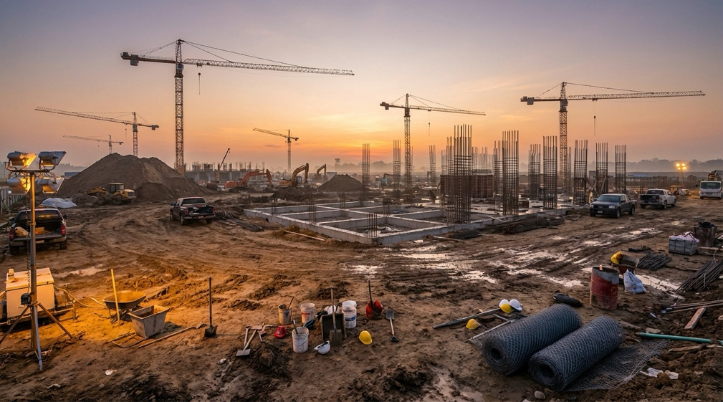

**Last Frame Bild**

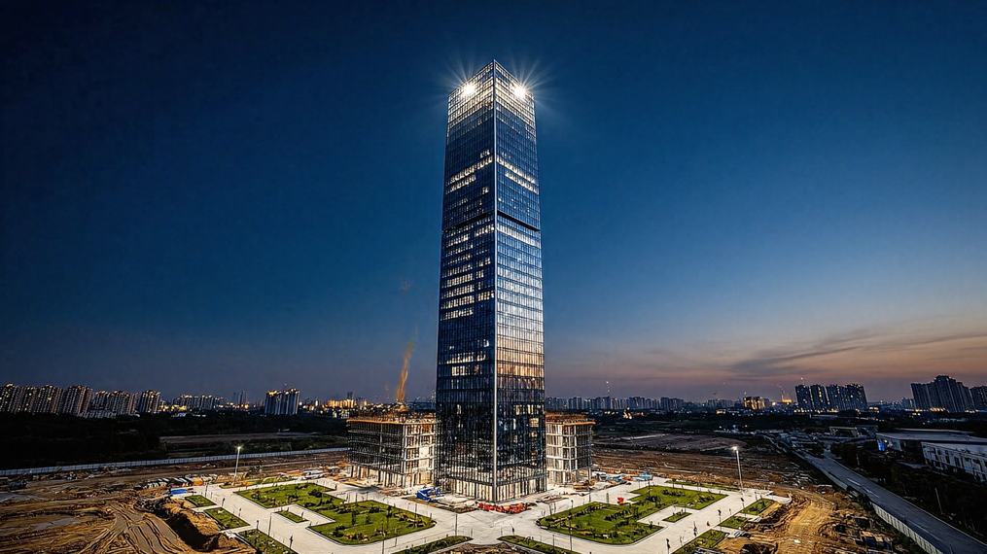

**Prompt für Timelapse Video**

Timelapse of a skyscraper being constructed from foundation to completion. Steel beams rise, floors stack, cranes move rapidly, glass panels installed, day cycles rapidly from sunrise to night repeatedly, finishing with a completed illuminated tower. Industrial high realism.

**Human Aging Portrait Foto**

**Prompt für die erste Szene – Portrait Foto**

Portrait of a young adult in warm morning window light, smooth skin, subtle expression, shallow depth of field, soft cinematic realism, blurred photos behind them.

**First Frame Bild**

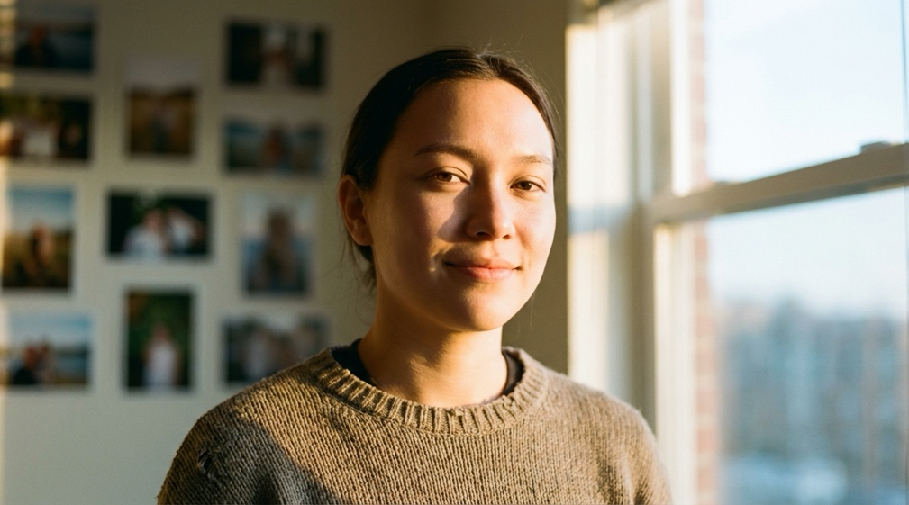

**Last Frame Bild**

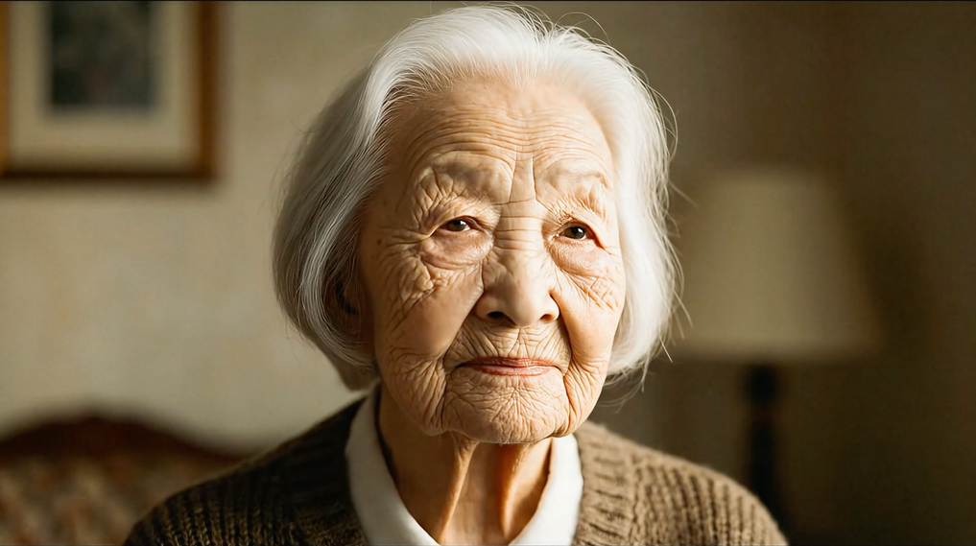

**Prompt für Timelapse Video**

Timelapse portrait showing visible aging across decades. Face gradually matures, wrinkles form, hair slowly turns gray, features deepen emotionally. Lighting and background evolve gently through seasons of life. Emotional, intimate storytelling transformation.

**Growing Mushroom Szene**

**Prompt für die erste Szene – Mushroom Foto**

Ultra-detailed macro close-up of a single wild mushroom growing on a moss-covered forest floor, dew droplets glistening on the cap, tiny spores and micro-textures visible. Soft shafts of sunlight filtering through dense trees in the background, bokeh highlights from moisture in the air, shallow depth of field, rich earthy tones, realistic soft ambient light. Small insects crawling on the stem, wet leaves and pine needles surrounding the base. Hyper-realistic nature photography style, 100mm macro lens, cinematic natural feel, 8K ultra-sharp clarity.

**First Frame Bild**

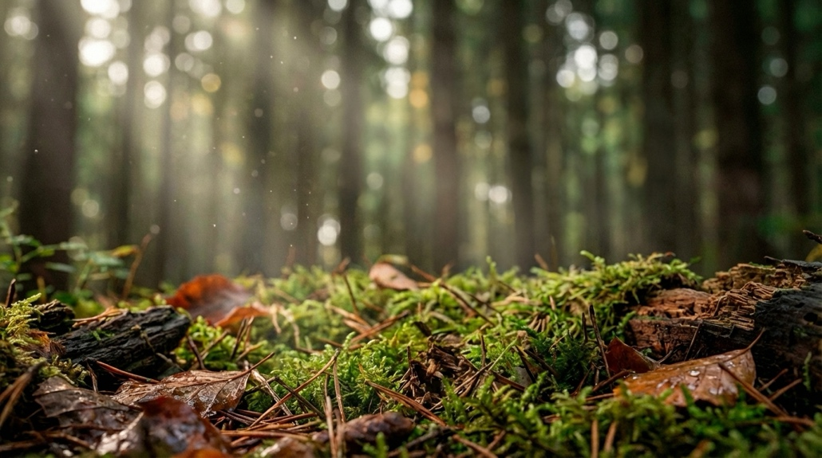

**Last Frame Bild**

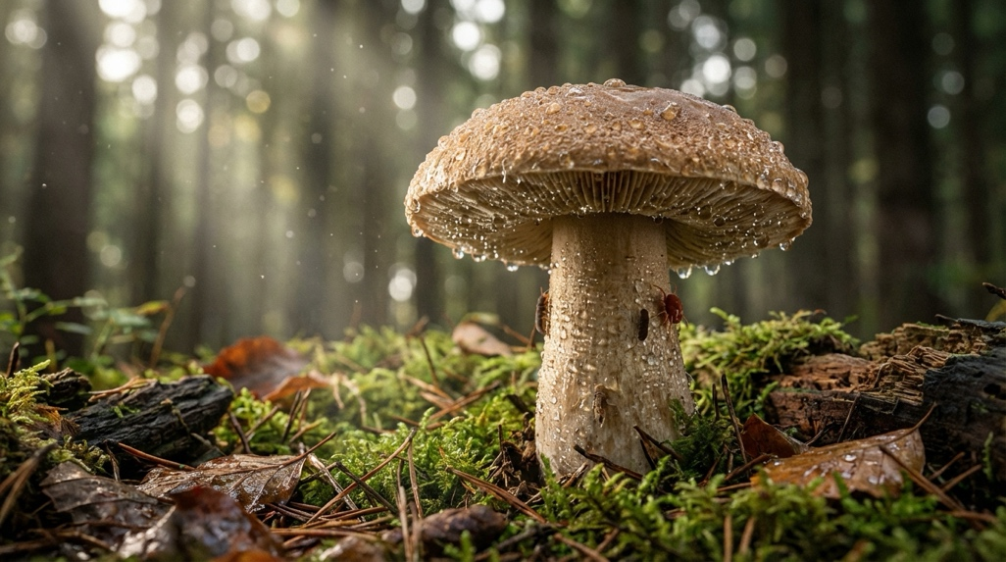

**Prompt für Timelapse Video**

Time lapse video of this mushroom growing in the woods, weather changing as well as day and night time

**Hochzeitsantrag**

**Prompt für die erste Szene – Marktplatz Foto**

High-altitude drone view above a busy European city plaza at golden hour, long warm shadows stretching across cobblestone, people walking, cafes and streetlights glowing, cinematic wide composition, soft sunset lighting, realistic scale and details.

**First Frame Bild**

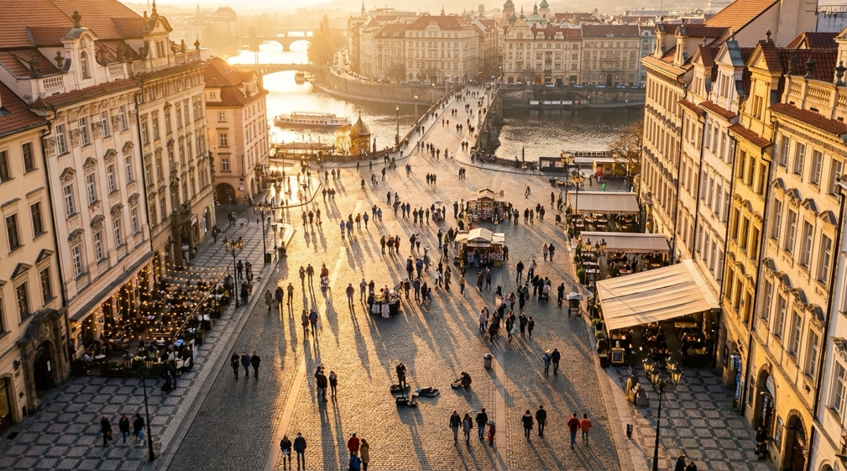

**Last Frame Bild**

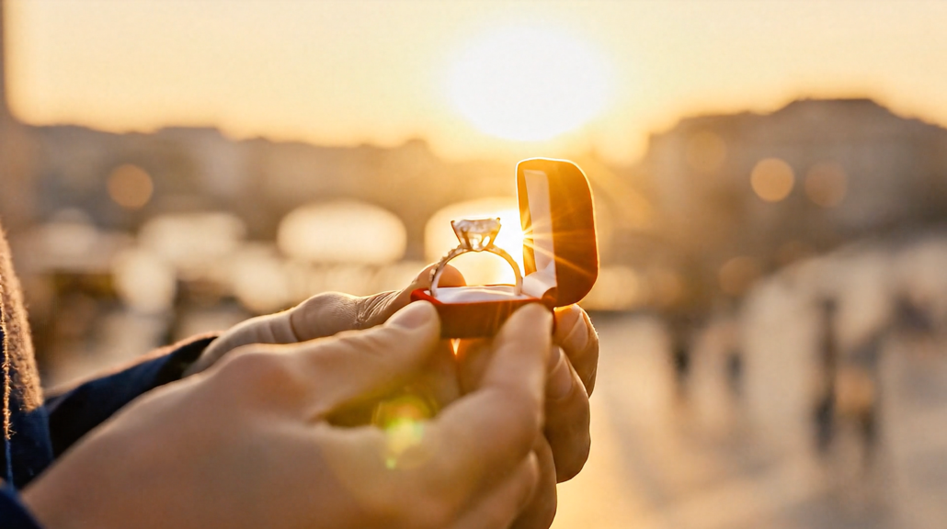

**Prompt für Timelapse Video**

Start as a top-down drone shot over a crowded plaza. Perform a smooth rapid aerial dive toward a kneeling person holding an engagement ring. As the camera arrives, execute a rack-focus shift: the background becomes soft bokeh blur while the ring surface becomes crystal-sharp, sparkling light reflections on the diamond dominating the frame. Film-style focus pull, natural lens breathing, emotional cinematic reveal.

**Ballet Studio Szene**

**Prompt für die erste Szene – Ballet Studio Foto**

Wide shot of a dancer standing in an empty rehearsal studio with floor-to-ceiling mirrors, morning light spilling across wooden floor, dancer frozen in starting position, studio quiet and still.

**First Frame Bild**

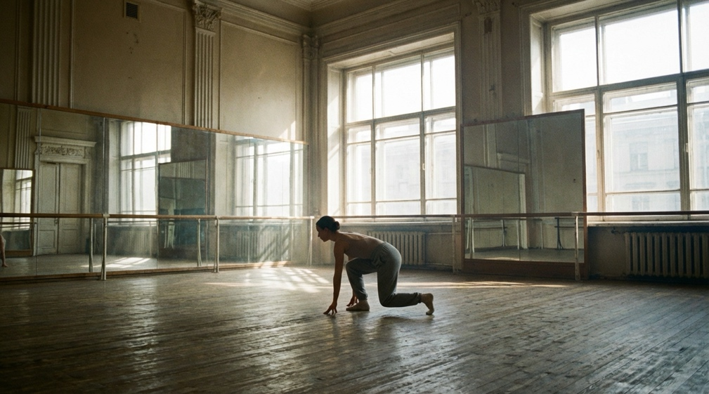

**Last Frame Bild**

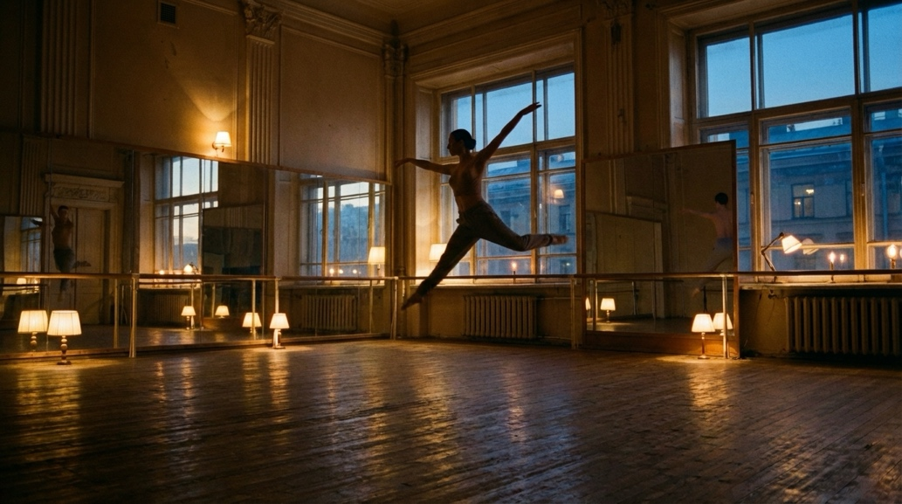

**Prompt für Timelapse Video**

Time Lapse video of her dancing there one camera shot just time-lapse